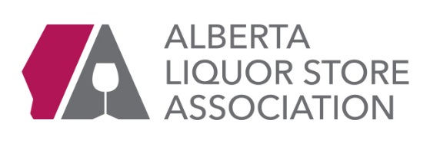

President’s Report
ALSA Board Meeting, September 6th, 2017

AGLC UPDATES

AGLC Board
Gael McLeod is AGLC's new Board Chair. Also Ken Knowles is back on the board

Price Schedule Change
AGLC agreed to post the change in prices on Thursdays, instead of Saturdays.

Special Event Licences
AGLC is finally moving forward with switching to an online service to issue private re-sale and non-sale licences. After the launch, AGLC would like to discontinue having retail liquor stores issues licences. They would like a short period where both the AGLC and RLS can issue licences, so that they can be assured the online system is functioning well with no “bugs”, after which it will go with online only.
AGLC would like to have a parallel process for 60 days. After the transition period is over and licenses are online only, AGLC will provide 30 days for stores to return their stock of licences to the AGLC for full refund. AGLC will not “force” a store to issue licences during the transition period, however would appreciate the stores that currently issue them to retain that capability in the unlikely event of a system failure or repair during start-up. This will likely be rolled out during ALIC.
Product Tastings
AGLC has finished drafting the new Product Tastings Regulations that has taken all of ALSA’s suggestions into consideration. AGLC has finished reviewing the regulations, they have released the draft to ALSA for comment. (Attached) This is likely going to be covered at ALIC 2017.

New Regulations for Alberta Manufactures
Farmer Markets – AGLC announced that all Alberta Liquor Manufacturers are now allowed to sell their products at Farmer’s Markets. In the past this only referred to craft breweries but now includes distilleries. ALSA requested clarification on the following:
Proserve Required: Yes
ID Under 25: No
18 Years Old: Yes
Samples: Yes
FASD Poster: No
Compliance Audits No
New Regulations for Alberta Manufactures (cont.’)
A newly created taproom licence will permit manufacturers to offer food service along with events and entertainment. These are often referred to as taprooms.
The Gaming and Liquor Regulation has also been amended so small manufacturers can operate licensed restaurants or bars away from where they produce.

Connect Logistics
Connect Logistics hit a record of deliveries during the week of June 25th – and July 1st, 2017 – total of 515,255 cases
ALSA is working on a government strategy to have the Warehouse RFP delayed until the construction of the building is completed. As it stands right now, the RFP process is to take place next year. By delaying the process, we can ensure stability in the system until the warehouse is build and also push the timeline closer to election year. AGLC has indicated to Connect Logistics to ‘not lobby’ on this issue. However as an industry association ALSA cannot afford to have a ‘wait and see’ attitude. A disruption to the system would be disastrous.

ALIC 2017
ALIC is coming together for October 16-17th in Calgary. These dates are just after the RMWFF takes place in Calgary. The dates were also chosen to coincide with AGLC Board meetings taking place in Calgary during that week.

The AGM and Awards reception will take place on Monday, October 16th, as well as a seminar with Jody Korchinski, VP Liquor Services and Dave Berry, Acting VP Compliance. We are expecting a bigger government turnout at this year’s reception.

On Tuesday, October 17th we have new Board Chair Gael McLeod, Minister Ceci participating in the Luncheon, and this year the key note Speaker will be Bruce Linton from Canopy Growers. Right after lunch there will be a seminar by Sundial Growers about economic opportunities in Alberta and leveraging the Liquor system for cannabis.

ALIC will be held at the Airport Marriot Hotel in Calgary.

Cannabis Legalization Update
- The Alberta Government has created a Cannabis Secretariat to conduct hearings and collect information on how Cannabis will be sold, distributed and stored. ALSA has been at the round table discussion that have taken place over the summer. The round table included stakeholders, legal cannabis producers, AGLC and aboriginal bands. Issues discussed included: Distribution and Retail Approaches, Economic Development, Security and Municipal Considerations. So far ALSA has the support of AHLA, Restaurants Canada, AUMA, Sundial Growers and Canopy Tweed licenced producers.

- Sundial Producers would like to establish a partnership with ALSA and ensure ALSA member stores are the only retail outlet for their products. Sundial Growers is one of three licenced producers in Alberta – and given the current Government’s support for “local producers’ in the liquor industry, this could be a great strategy to support ALSA’s position on the retail of recreational cannabis. A good narrative around Alberta Economic development and diversification.

- Attached to your documents is a research paper that describes why co-location with Alberta Liquor stores is the best option for Alberta for your perusal

ALSA has been invited to speak at a conference in Toronto in early October (Oct 4, 2017) for institutional investors in North America being hosted by the investment bank Dundee Capital Markets. Leading up to the anticipated legalization of cannabis for recreational / adult use, Dundee believes investors would be wise to get a better understanding of the regulatory process in Alberta. A good opportunity to educate and perhaps put some pressure on the provincial governments on the I ue.

Here is the information provided to the secretariat from ALSA.

Responsible Distribution of Recreational Marijuana

Alberta Liquor Stores have been preparing for this moment since 1993
For over two decades, the members of the Alberta Liquor Stores Association (ALSA) have been selling alcohol, the only legal controlled substance in Canada, safely and responsibly in the Province.
We have a proven record of safely delivering alcohol to Albertans daily, thanks to trained staff, responsible marketing communications and genuine connections to the communities we live and operate in. This is our home too and we want to make sure our children are protected and that controlled substances, whether alcohol or recreational marijuana, are distributed and sold safely.

ALSA believes the current Alberta Liquor Model, which provides for public distribution oversight and government-regulated private retail stores meets the main policy objectives of the Alberta Government:
Keep cannabis out of the hands of children and youth • Protect public health • Promote safety on roads, in workplaces and in public spaces • Limit the illegal cannabis market

THE ALBERTA LIQUOR MODEL

PROTECTING OUR CHILDREN
- Minors are not allowed into liquor stores
- Liquor stores must ID anyone under the age of 25 – It’s the law – Compliance by AGLC
- Alberta Liquor Stores are already zoned by municipalities to sell or a controlled substance and to be a safe distance from schools and playgrounds
- Every liquor owner must go through a police background check before receiving a Class D license

RIGHT TRAINING ALREADY EXISTS
- Every liquor store owner, operator, manager and staff is required to take government sanctioned training courses – ProServe
- Added in store training programs go above and beyond regulated standards - providing safe and responsible service is good for business

HOLDING OURSELVES ACCOUNTABLE
- Liquor retailers work closely with AGLC, AHS, AB Transportation, Students against Drinking and Driving (SADD), municipalities, community associations and police services across the province to bring awareness about responsible alcohol consumption. These include supporting awareness programs about Fetal Alcohol Spectrum Disorder (FASD), Drinking and Driving, responsible consumption and support AGLC’s Drink Sense Campaign to promote Health Canada’s Low Risk Alcohol Drinking Guidelines
- Liquor retailers are committed to safe communities for all Albertans

INFRASTRUCTURE ALREADY EXISTS
- Currently Alberta has 1,400 liquor retailers across 350 towns and cities across the Province, already zoned to be away from Schools and Playgrounds.
- 65 % of liquor retailers in Alberta are independent – Family owned and operated
- AGLC contracted warehouse and distributor, Connect Logistics Services handles the fulfillment of over 100,000 orders annually, shipping over 14 million cases of product
- Centralized warehousing system in Alberta ensures efficiencies that are passed on to the system and provides for close oversight by AGLC. Distribution in Alberta is a postage stamp system that charges the same delivery cost to every liquor store, regardless of the geographical region in the province. This provides for a level playing field for every liquor store in Alberta.

ALBERTA MODEL OF LIQUOR RETAILING IS THE BEST OPTION FOR RECREATIONAL CANNABIS

Alberta is the only province in Canada with a fully privatized liquor retail system. This means that Alberta’s approach to recreational Cannabis distribution will be vastly different than other provinces. Liquor is regulated by the Alberta Gaming and Liquor Commission, the same as liquor commissions in the rest of the country. The difference is that Alberta has Public Distribution Oversight and Government Regulated Private Retail stores. Same regulations and laws apply to private liquor stores in Alberta as in Government run liquor systems.

- TIME IS OF THE ESSENCE
Given the extremely tight deadlines for the legalization of Marijuana from the Federal Government and the high costs of building new infrastructure, ALSA is of the opinion that leveraging the existing provincial liquor model and its infrastructure is the most viable option for the Alberta Government.

- LENGTHY AND EXPENSIVE PROCESS IF NEW INFRASTRUCTURE IS REQUIRED
Alberta already has extensive infrastructure throughout the province, licensed and zoned to sell a controlled substance. If new infrastructure is required, it would take on average 4 to 6 months to obtain a development permit, business license and liquor permit (Calgary and Edmonton) per store. Average expenditure associated with leasing space and inventory (without salaries or application fees) per store: $385K - $735K (Appendix A)

- CURRENT LIQUOR MODEL CAN BE LEVERAGED FOR CANNABIS
Public Distribution Oversight and Government Regulated Private Retail is the current model used by the Alberta Gaming and Liquor Commission: Liquor distribution is run by government but operated by a private third party contractor and overseen by the Alberta government.
- Puts distribution operations in the hands of those with the experience. The new AGLC Warehouse will have state of the art technology and modifications can be made to meet the requirements of Cannabis in consultation with licensed producers. Efficiencies can be reached by combining the delivery of both liquor and cannabis to the same locations
- All products bound for retail sale in Alberta are controlled by AGLC
- Only authorized and government licensed retail stores can sell liquor (Cannabis)
- Retail stores sell liquor (cannabis) based on rules set by the Alberta government (e.g., training requirements, hours open) and municipalities (e.g., zoning rules).
- The Alberta government already has the regulatory body to oversee licensing review and approval, compliance and enforcement of retail organizations via AGLC. A new department could be added to AGLC to handle Cannabis, much like the Liquor Services department handles liquor. This would allow for a coordinated approach in regulating both substances.

RECOMMENDED MODIFICATIONS FOR CANNABIS RETAIL

- Liquor owners must go through a police background check before a liquor license is issued. Given the current illegal component of cannabis, ALSA would recommend making background checks for cannabis licensing in line with the security checks for Casino operators. Casinos go through a more comprehensive security and financial background check which is required by AGLC before a casino license is approved.
- Training for selling Cannabis can be developed by AGLC in consultation with industry, and delivered in the same manner that ProServe training works for liquor retailing.
- ID under 25 law is enforced by AGLC compliance officers. ALSA would recommend stronger regulations for identification for Cannabis sales:
- Make showing ID mandatory. This would eliminate guessing if someone looks to be under 25, therefore making it more secure and reduce the need for enforcement.
- Introduce regulation to allow compliance officers to fine individual persons that do not ID. Currently only owners can be fined and there is no accountability for those who choose not to ID at the checkout. Other jurisdictions such as Alaska and British Columbia already do this.
- Regulations and guidelines for Cannabis should be ‘black and white’ so that there is no room for interpretation on the regulations from either the retailer or compliance officers.
- AGLC Compliance Officers carry out regular audits and visits to Liquor stores throughout the year. While on premise, these visits can be leveraged to also carry out audits for the sale of Cannabis

RECREATIONAL CANNABIS SALES CAN BE SOLD IN SAME LOCATION AS LIQUOR SALES

LIQUOR STORES ONLY WANT TO RETAIL RECREATIONAL CANNABIS.
ALSA and its members believe that there needs to be a two prong system for cannabis: medicinal and recreational. Our members feel that cannabis prescribed for medicine purposes is best left to pharmacies, where the patient’s prescription history can be assessed by professionals to best advice on individual drug interactions.

NO RESTRICTIONS ON CO-LOCATION FROM FEDERAL LEGISLATION
The Federal Government rejected the Task Force on Cannabis’ recommendation to prohibit the co-location of recreational marijuana and alcohol sales. The Task Force’s recommendation ignored the decades-long track record Alberta’s private liquor retailers have earned when it comes to the responsible sale of controlled substances and ALSA is pleased Ottawa agrees.

Keeping marijuana products away from children is paramount when legalization happens

Our members have been doing this with alcohol for over 20 years and would do so with marijuana, should the provincial government choose to co-locate alcohol and marijuana sales.

MUNICIPAL ZONING ALREADY EXISTS
- Liquor stores are already zoned by municipalities to sell a controlled substance and to be at a safe distance from schools and playgrounds. This means that cannabis can be sold in the same location as liquor, but separately without violating municipal distance bylaws.

SAME LOCATION-SEPARATE ENTRANCE – BETTER EDUCATION
- Cannabis will be a new drug to majority of people and the nature of cannabis will require a different manner in which it will be is sold
- Tobacco ‘store-style’ counters, with cannabis products behind shelves is a more conducive way of selling cannabis. This will provide for one on one interactions with customers and the ability to offer the best type of advice and education on products and its potential effects on a personalized manner. Liquor stores already conduct awareness programs and educational seminars on the effects of alcohol, therefore in the best position to educate consumers on the risks associated with consuming both alcohol and cannabis at the point of sale
- As recreational products are developed, staff can be trained to fully understand the THC level of each product to better advice customers and better educate about the effects of the cannabis product and mixing alcohol
- Options include: Store within a store (aka Starbucks inside a Safeway) or a separate entrance.
- A separate entrance can be accomplished by dividing a subsection of a standing liquor store to accommodate a separate area and entrance for customers. It would be ALSA’s recommendation to have a double door entrance with a vetting and reception lounge area for verification of age.

Example of what a cannabis retail space could look like in a liquor store with a separate entrance:
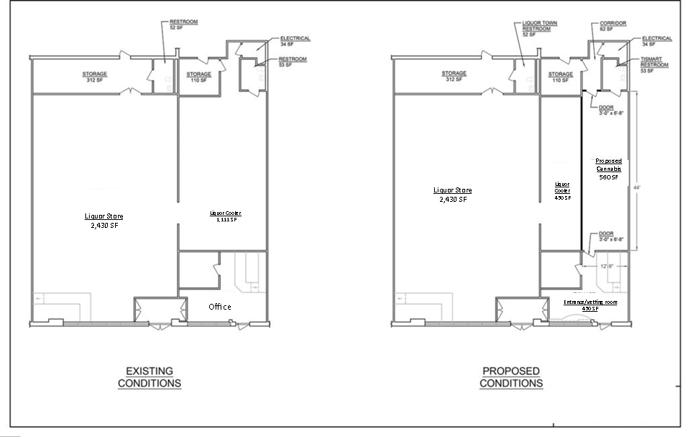

- Albertans feel it is very important to have retail stores with the right training and experience selling a controlled substance, sell cannabis. This was the overwhelming response to a province wide survey about cannabis conducted for ALSA earlier this year.

The AHLA strongly supports leveraging Alberta's existing liquor industry model for distributing,
THE RIGHT NUMBER OF CANNABIS LICENCES
The Alberta Government has expressed concerns with the proliferation of Cannabis Retail Stores. This is a legitimate concern that needs to be looked at to find the right number of retail stores for Alberta. ALSA is of the opinion that the Alberta Government should set a limit of licenses to be released for the purposes of cannabis sales. Looking at other jurisdictions, there are several examples that can be used as bench marks.
- British Columbia Government has capped the number of liquor licenses and enforced a 1 km separation distance
- Oregon and Colorado are closer in population to Alberta. These jurisdictions have linked the number of cannabis licenses to population
- ALSA would recommend using a ratio of licences to population :
  - 1 Cannabis License for 8,000/10,000 people
  - This works out to 400-500 initial licenses, with the ability to increase as deemed necessary by the Alberta Government
  - Can be accomplished by either a lottery, auction or RFP process

Minimum Age for purchasing Cannabis
ALSA supports the minimum age of 18 years to purchase cannabis. This aligns with the Federal Government’s legislation and Alberta’s drinking age. If the Alberta Government would like to increase the age of consumption for cannabis, ALSA strongly recommends coordination with other provinces.
- ALSA recommends mandatory ID to purchase recreational cannabis

Summary
ALSA strongly supports leveraging Alberta's existing liquor industry model for distributing, retailing, and regulating recreational cannabis. Given the short timelines for implementation, the Alberta model can be easily adapted to accommodate cannabis retail while taking advantage of an existing, strong regulatory and compliance system that provides efficiency and cost effectiveness for Government. It would also provide for the safe and responsible retail and distribution of recreational cannabis.

APPENDIX A
Process for Zoning - Liquor Use : (Edmonton)

- Timeline
It normally takes 60 to 90 days for a development permit to be received from City of Edmonton. If there is any opposition from residents or nearby business, the permit will be sent to a hearing at the Sub Development Appeal Board (SDAB). This could add a couple of weeks to the process.

Once all requirements are met from the City it takes 3 weeks to receive the liquor permit from AGLC if no issues arise. If appeals are submitted at this stage, it could take a few months before there is an AGLC hearing.

Average timeframe: 4 to 6 months
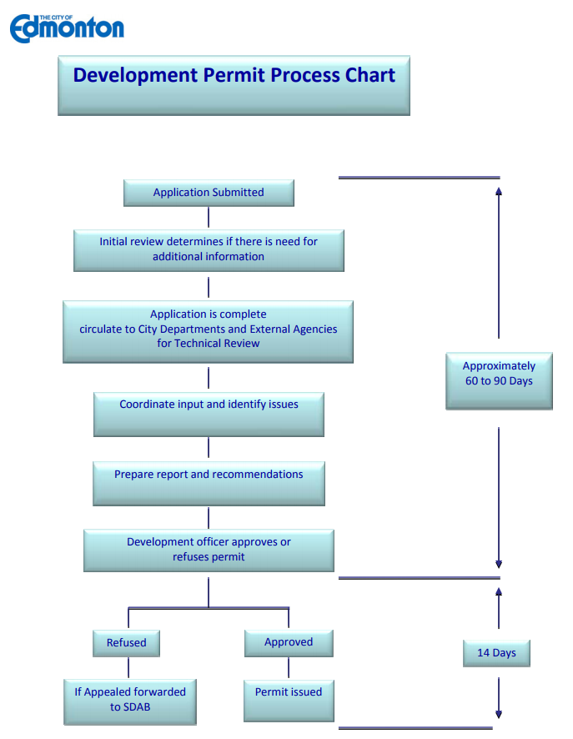
- Costs associated with obtaining a license – Applications (City of Edmonton)
Development Permit Application: https://www.edmonton.ca/documents/Commercial_Development_Permit_Application_.pdf
Fees: https://www.edmonton.ca/documents/2017_Development_Permit_and_Compliance_Fees.pdf
Checklist: https://www.edmonton.ca/documents/Commercial_Industrial_checklist.pdf
Change of Use Checklist: https://www.edmonton.ca/documents/Change_of_Use_Checklist.pdf

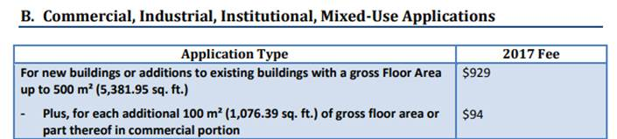
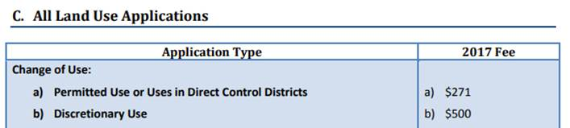
Average application cost per retail space: $2,148
**Additional Fees are not listed, such as Fire Inspections, etc.

- Lease Space
Average between Calgary & Edmonton is:
$35.00 per sq. plus Operations (Maintenance, taxes, etc) which is another $10 to $12
Total: $45.00 to $47.00 per sq.
- Average Size of Space: 3,000 sq. to 5,000 sq.

- Average Inventory on Premise: $250K to $500K

- Number of Employees: 3 to 5 per shift (minimum)

- Wages for Employees: $20 to $25 (not including benefits)

- Average Expenditure (without salaries or application fees) per store: 385K - 735K

